EGU Meeting Agenda
November 20, 2020
4:00 PM - 5:00 PM

https://arizona.zoom.us/j/96754693926
Password: 363653

Officers Present: | Sovay, Claire, Alyx, Analeigh, Lauren, Marisa, Josie, Martin, Kelli, Hongni, Leah, Eric, Casey, Hannah
Visitors Present: | Dalia, Hannah, Jazzie

PROPOSED AGENDA:
- Opening ~5-minute quiet reading buffer time to review rep reports and co-chair reports
- Discussion of most pressing or largest topics
- Individual committee meetings, if time
- Project/committee reports: Could each committee come to our final meeting on Dec. 4th with a report on what they’ve done this semester and what they plan to do in spring (if applicable). Touch bases on this and also what people would like to do at the final meeting. Plan for spring? (5 minutes near end)
- Martin’s final thoughts: a nice pep talk (last 5 minutes)

Co-Chair Discussion Items (Sovay and Martin)
Spam issue: how can we address this?
The EGU Co-Chair email is separate from the Arizona system for protection, but this means now that the emails go straight to spam, being out of the system.
(https://it.arizona.edu/documentation/spam-and-junk-email-rules)
Notes from meeting with Shelley (Martin)
- Last meeting is Dec.
Notes from meeting with Aurelie (Sovay)
- Aurelie will set up an open Zoom meeting with the Health Insurance Office on campus for graduate students to attend. This was prompted by folks having anxiety about what their policy covers and what it doesn’t cover. According to him, nothing in our policy has changed for spring semester, so it appears that that particular rumor may have been apocryphal. This meeting will hopefully be announced soon.
  - A comment confirms the above: The policy has changed for the open-enrollment for this round. If you were enrolled for fall and Spring, then you will not need to enroll during this Spring enrollment period.
- Re. the recent (but historic/ongoing) issue between the WP, the textbook policy, and graduate students: Aurelie has asked that the EGU compile a list of questions/fears/concerns that can be sent to Aurelie and Shelley R. that they can discuss together. What has been clear and has been made even more clear this semester is that the triangular dynamic (between the WP, the textbook policy, and graduate students) is toxic and isn’t working well. Aurelie is in communication with the department as a whole about how this dynamic can be changed. Please add items to this list.
- The issue of professionalism and email etiquette has become a topic of discussion in the department. This is something that Council and the department head are discussing right now. Happy to elaborate on this if there are questions.
Notes from Department Meeting (Martin)
- Next Dept. Meeting Dec. 4th
Notes from PD Meeting (Sovay)
- As EGU co-chair I have been asked to serve as the grad rep on the small department committee (made up of the PDs, Department head, and some other English faculty) to strategize a proposal to present to Provost Folks about the future of our department and particularly GAT funding. Our meeting is December 11th. This meeting has the potential to have an enormous impact on future English graduate education at the U of A. The faculty are going to first ask Folks what her vision is for us and then make a counter proposal to suggest a sustainable model for the future of our department. I will keep you reps apprised of the outcome of that through Martin and Hannah, who will obvi be co-chairs next semester. My goal at this meeting is to ingratiate myself, on behalf of English graduate students, with the Provost so that she sees us as a group of valuable professionals who are worth funding (ew, I know, but this is the language she speaks). My other goal is to try to set a precedent of graduate students being consulted and involved in decisions about graduate education.

- I’ve also been attending the MLA Summit on the Future of Doctoral Education as the graduate student delegate in our department’s delegation (with Drs. Cristina Ramirez and Manya Lempert). The delegation will meet this coming Monday to discuss our takeaways from the Summit and to propose changes to the department based on what we’ve learned. I will be very excited to present this to you all at our final EGU meeting on December 4. It is quite clear that the future of graduate education requires that departments keep their pedagogies and curriculums relevant and adapted to the job market. More soon.
Discussion items from Reps
- Secretary (Claire):
  - Last meeting’s minutes for approval (11/6)
  - All approved minutes can be found on the EGU page here.
- First-Year (Josie):
  - No news.
- EDI (Alyx and Claire):
  - Claire: Alyx, Kelli and I met last Friday and today to talk about goals when writing form language that all English graduate students may use in responding to threatening emails or situations. We also began drafting meeting protocol for conversations between complainants and accused as well as a formal position statement about expected and proper communication between graduate students and admin.
    - We welcome editing on the formal statement and protocol.
Another update is that we both have heard a grievance from current first year students about repeated behavior from a particular Preceptor. We have advised them to wait until we could meet today to figure out a plan, as OIE could be a long and involved process and AIME is not built for internal reviews of this sort.
- A different rep invited one of these students to join us today because they came to me as well, so they thought this was a very important thing for us to address. It's not isolated to just the preceptor, unfortunately, and the WP has been very unhelpful with regard to helping at least this student out of this situation. For the time being the rep knows at least the student who came to them has also gone to Lynda with their concerns.
  - There is general consensus on this point, as seen in the conversation portion of the minutes.
- Alyx: will attend AIME meeting on Nov. 30th

- WriPACA (Leah, Lauren, Marisa):
  - General:
    - Next meeting is 12/1
    - Reminder on who leads each subcommittee:
      - By-laws: Alan
      - Curriculum and Instructional Materials: Shelley Staples
      - Assessment: Erin Whittig and Catrina Mitchum
      - D&I: Dev Bose
  - Bylaws (Leah):
    - The meeting was canceled this week. Alan is going to email the current draft of the by-laws voting policy to the entire Writing Program for feedback. I believe anyone will be able to comment on the document, and then there will be a time to discuss all feedback and ask questions at the next WriPACA general meeting (12/1). The feedback will be used to revise the draft at the beginning of next semester.
      - In answer to a question, there appears to not be a set date for revisions, but they want to move quickly because the voting policy is not the only part of the by-laws that need revised and voted on by the end of next semester. I would imagine early next semester after we take the feedback into consideration.
    - The current draft says “graduate student representatives” rather than “EGU representatives” and includes the Writing Program facilitating the voting process for representatives. Kelli, Hannah, and I met last week to discuss language we could propose to revert back to “EGU representatives” and to allow EGU to continue to facilitate the voting for our reps.
    - Once the draft is sent out, I would really like to hear your questions and concerns as well. (leahbowshier@email.arizona.edu)
  - Assessment (Marisa):
    - Today’s meeting we discussed the 2019-2020 portfolio assessment reflections and recommendations:
      - Because there was a balance split between advanced, intermediate, and easy portfolio options and the portfolio type did not appear to have a noticeable impact on engagement, we’re recommending the WP continue to offer instructors and students a range of portfolio options: Spark, G-Drive folders, Docs, etc.
      - Our relatively small sample prevented us from drawing strong conclusions about student engagement by race/ethnicity; however, we will continue to disaggregate our portfolio results by race/ethnicity in order to track patterns or trends that might emerge over time and recommend including socioeconomic and first-generation status for disaggregation.
    - At the 12/14 WP open meeting we’ll be brainstorming different portfolio teaching strategies (How do we encourage students to reflect on their class engagement in meaningful ways rather than effusive empty praise?) and gather feedback from faculty on what an “engaged” student looks like right now.
  - Curriculum (Lauren Harvey):
    - The most recent meeting was spent discussing the new chapters for the Students’ Guide that correspond to the new reflection SLO
    - We put off discussing OER stuff to get the feedback to the editors ASAP
    - The next meeting is cancelled (December 8), so we will next meet in January.

- CW (Hannah):
  - No news
- EAL (Eric): No news
- RCTE (Analeigh): no news
- Lit (Casey): No news, no meeting this week or last.
- SLAT (Hongni):
  - SLAT is accepting applications this year, but funding may not be guaranteed.
  - SLAT Roundtable Call For Papers. The 20th Annual Interdisciplinary SLAT Roundtable will be held on February 6, 2021. Proposals from all fields doing language work particularly L2 language teaching, learning, administration, and research are welcomed!
- GPSC (Kelli):
  - Free grab-n-go Thanksgiving meal for grad students (and household).
    - Register Here: https://www.eventbrite.com/e/gpsc-thanksgiving-meals-registration-129590132575
  - Lisa Runley UArizona Senior Vice President and CFO and Garth Perry from Business office came to talk about
  - University tuition and fees -
    - Emphasized University budget is dependent on state budget
    - See Appendix below with details on Budget, Tuition, and fees
    - Pointed questions -
      - “Do those in executive leadership positions expect to take pay cuts next year to help with the financial situation? Or will the burden still be on all employees”
        - Business office doesn’t expect the furlough program to continue. Seeking other strategies.
      - “What measures do you have in mind as an alternative for layoffs and furlough”
        - There's a financial sustainability task force - there are increased expenses (including the creation of buildings to house new grants)
      - “When will Furlough end?”
        - Complicated. there are two kinds of furlough - all details on HR website
    - Conversation
      - One rep looked over the Financial Report of the University for 2020 (the fiscal year begins July 1st and ends June 30th). From their perspective (which is limited), it seems most of the debt that has contributed to the downward fluctuation has come from long-term debt/loans/bonds (that is catching up) and from Pensions/OPEB. However, the amount of money spent on "Instruction" has outweighed the amount of money spent on "Research" and they assume this push by Provost Folks to restructure the Dept. is a push to increase Research over Instruction. The University from 2019 to 2020 changed (~7%) while previously it was up 2.5%. So, from this perspective, COVID did not have the impact that was speculated nor is Dept. being costly as stated
      - Another rep noted that enrollment did not decrease this year as projected and heard a rumor it actually think it increased. A third confirms hearing this as well.
      - A rep confirmed that the enrollment for First Year Writing courses didn't decrease, but the tuition for student's enrolled changed. There was a bigger “melt”. They were not entirely sure about enrollment university wide.
      - Kelli said that this was not mentioned in the meeting – they only mentioned that revenues from enrollment did not decrease as much as predicted.
  - ASUA Arizona Students for Sustainability proposes a mandatory $10 fee which will apply to incoming students. They need student input: https://uarizona.co1.qualtrics.com/jfe/form/SV_eG4vxhRV6VHWVyl
    - “This student fee supports the development and implementation of large-scale, student-led, campus-based sustainability projects. The fee money will be awarded based on the potential impact of the project in terms regarding campus carbon offset, waste reduction, energy and water efficiency, and social aspects of sustainability (e.g.social justice). Projects will be highly visible and prioritize education of the University of Arizona and Tucson communities, demonstrating university responsibility and environmental leadership. The Sustainability Fee will also provide University of Arizona students opportunities to gain hands on educational and leadership experience leading sustainability projects. The proposed fee will be mandatory for the first 5 years in effect, after which the Sustainability Fee Board will reevaluate the mandatory status and may decide to make the fee optional.”
      - There were a few comments on this new fee, to the effect that it represents an idea that the students are the main ecological burden on campus, when in actuality the school wouldn't exist without them.
      - Additionally, while housing thousands of students is costly, but this year, they likely saved money in this regard.
- Lit Grad Curriculum (Casey): No news--if you need a language waiver (for whatever reason) Language requirements are being waived by the Lit program for those impacted by the pandemic. I’m not sure whether this also applies to other programs, but if you are in lit and have not yet taken a language exam/qualified for your language requirement, email Lynda.
  - A rep confirms that it is a simple process: she emailed Lynda for a waiver. She recommends hanging on to the email response in case.
  - Another rep asks if RCTE could request a waiver like this for ICR.
- Undergrad Curriculum (Colleen):
- Social Chair (Ruixue): Nothing new. But I am thinking of organizing some online grading event since it’s almost the end of the semester.

Projects/Tasks
- Constitution Revision
  - No updates
- Finish/continue working on new grad student guide
  - No updates
- Archival work to include on our website on the English department page?
  - No updates

Conversation:
- What do we plan on doing for spring?
  - Come with information about emergency appointments/changes coming in the spring
  - Come with your accomplishments!
  - Come with your committee reports and a timeline for those projects.

Questions:
- A first year grad just asked me if there is any EGU travel funding this year--any news?
  - Check GPSC for travel funding, since they allow those funds for digital conferences this semester and next.

New Concerns:
- A couple of Literature students have reached out to a rep with some concerns about harassment and/or some heavy persuasion that is going on in the WP.
  - One grad student (who has also been in touch with EDI) is being harassed by another student in their preceptorship and is being subjected to racist comments by their preceptor. So far, it seems that the WP is pretty uninterested in helping this student or providing resources for them to get out of this situation. Is there anything we can do as a student organization to support this student?
    - Comment: this involves the entire department of English, as this is a historic and large problem beyond even preceptorship.
      - How do we continue forward?
      - Bringing attention to AIME to include preceptorship in the climate survey.
    - Shelley, as the apparent appointer of preceptors, might be the first place to go.
      - At least one student has gone to \the Writing Program and not received help.
      - We need to address the fact that there is no protocol when we bring this up, as it is a gap that must be continued.
      - Follow up with the participants about their specific goals and come with different options for them to choose from.
        - We can stand behind people with letters, presence, and calling for this change.
      - What is the process when their request seems impossible (switching classes)?
      - Flow-chart on how to report sexual harassment forthcoming
  - Two other lit grads who are teaching a split prep in the spring have reported heavily intoned persuasion that they won’t be able to hack it (my words) and encourages them to drop the split prep and teach two 102 sections instead. Have others received emails like this?
    - Split prep is clarified as teaching two different courses in the same semester.
    - Going forward, it might be helpful to CC at least one of the EDI reps that when EGU members receive student complaints via email (provided folks are comfortable doing this)
    - Additionally, the EDI co-chairs ask if students feel comfortable sending on the correspondence they receive to EDI – the goal is to keep an archive of these events. Additionally, if people feel uncomfortable having their names on the email, the chairs suggest copy and pasting the language into a document with notes about the person’s position to retain anonymity.
    - Reporting through texting does make this harder to send on – perhaps we can think of solutions.
- The issue of terms rolling over during winter break comes up and takes us by surprise. We should discuss whether those involved are willing to stay on through next semester to keep us on cycle. Elections for fall will obviously be held in spring, but we should think more about ad hoc processes in the future.

Going Forward:
- Continue making clear our value to the university and to make us more visible on campus
- Possible share rationale behind by-laws decisions between the grad student reps
- Do we want to make a Slack and beta-test using it for ongoing discussion?:

More Ways to Get Involved:
- CAJUArizona (on Instagram under this tag)
- Attend Department Meetings
- Attend Open Hour meetings
  - English & WP Open Meetings
    - Fridays (https://arizona.zoom.us/j/94211011308)
      - 1:30pm-2:30pm: 9/18
      - 3:00pm-4:00pm: 9/11, 10/9, 11/6, 11/20
Appendix:

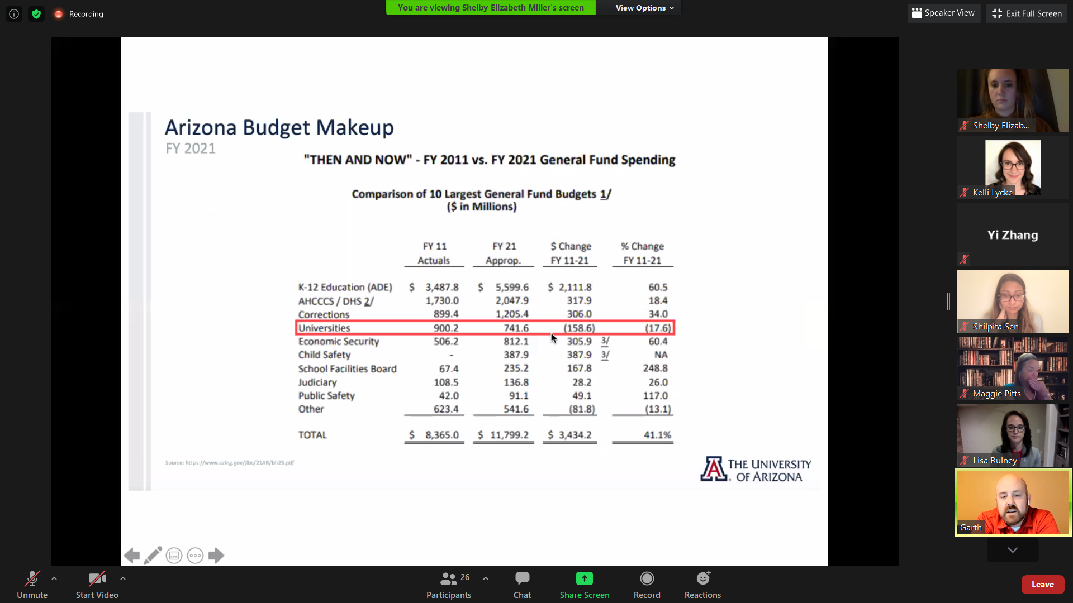
State Budget - Includes UArizona and Arizona State.
- These numbers may not be adjusted for inflation. Tuition and fee changes account for inflation with each increase though.

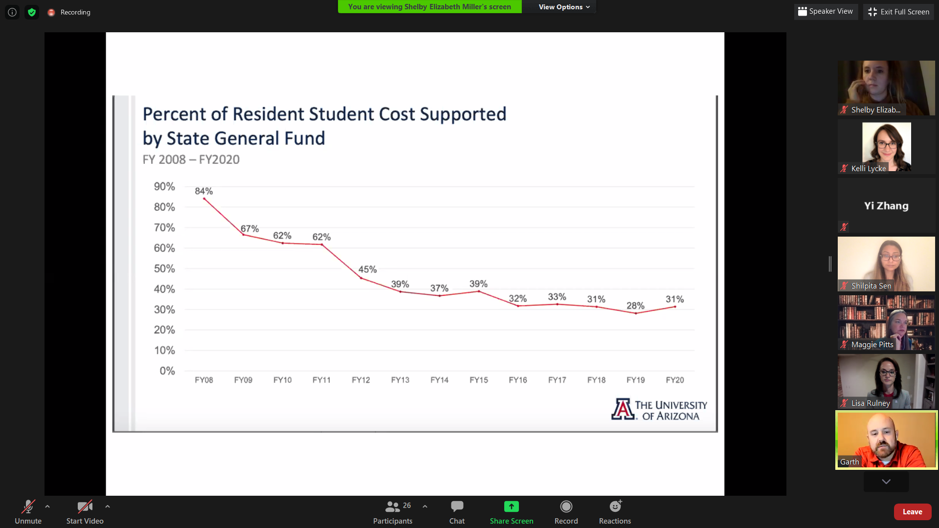
Percentage of State Resident Students at UArizona - we top the list of in-state decline across the union.

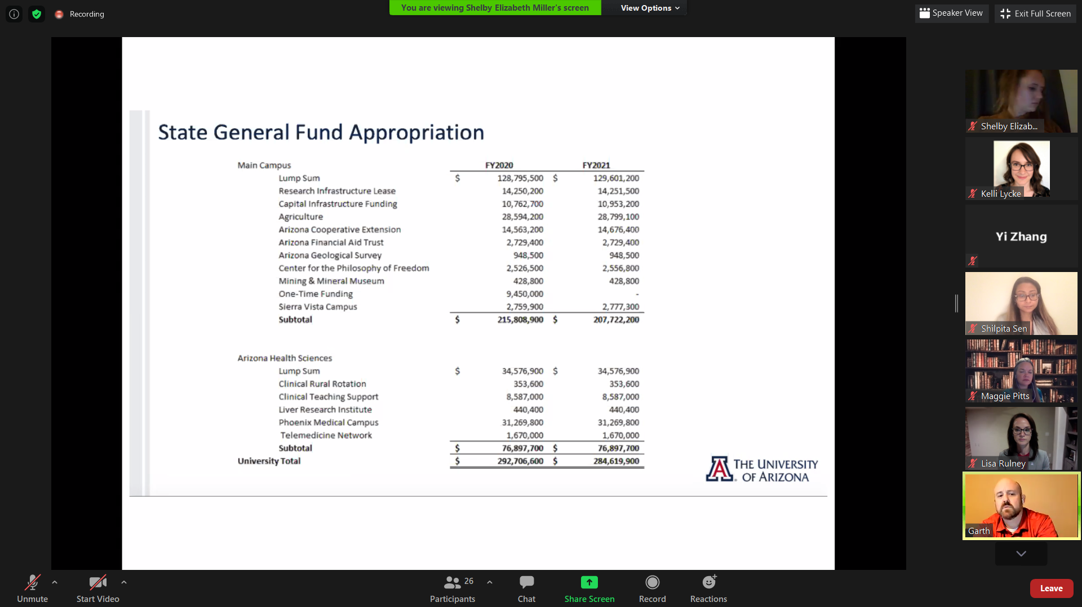
line-item tax appropriations. Moneys have to be used for these purposes.

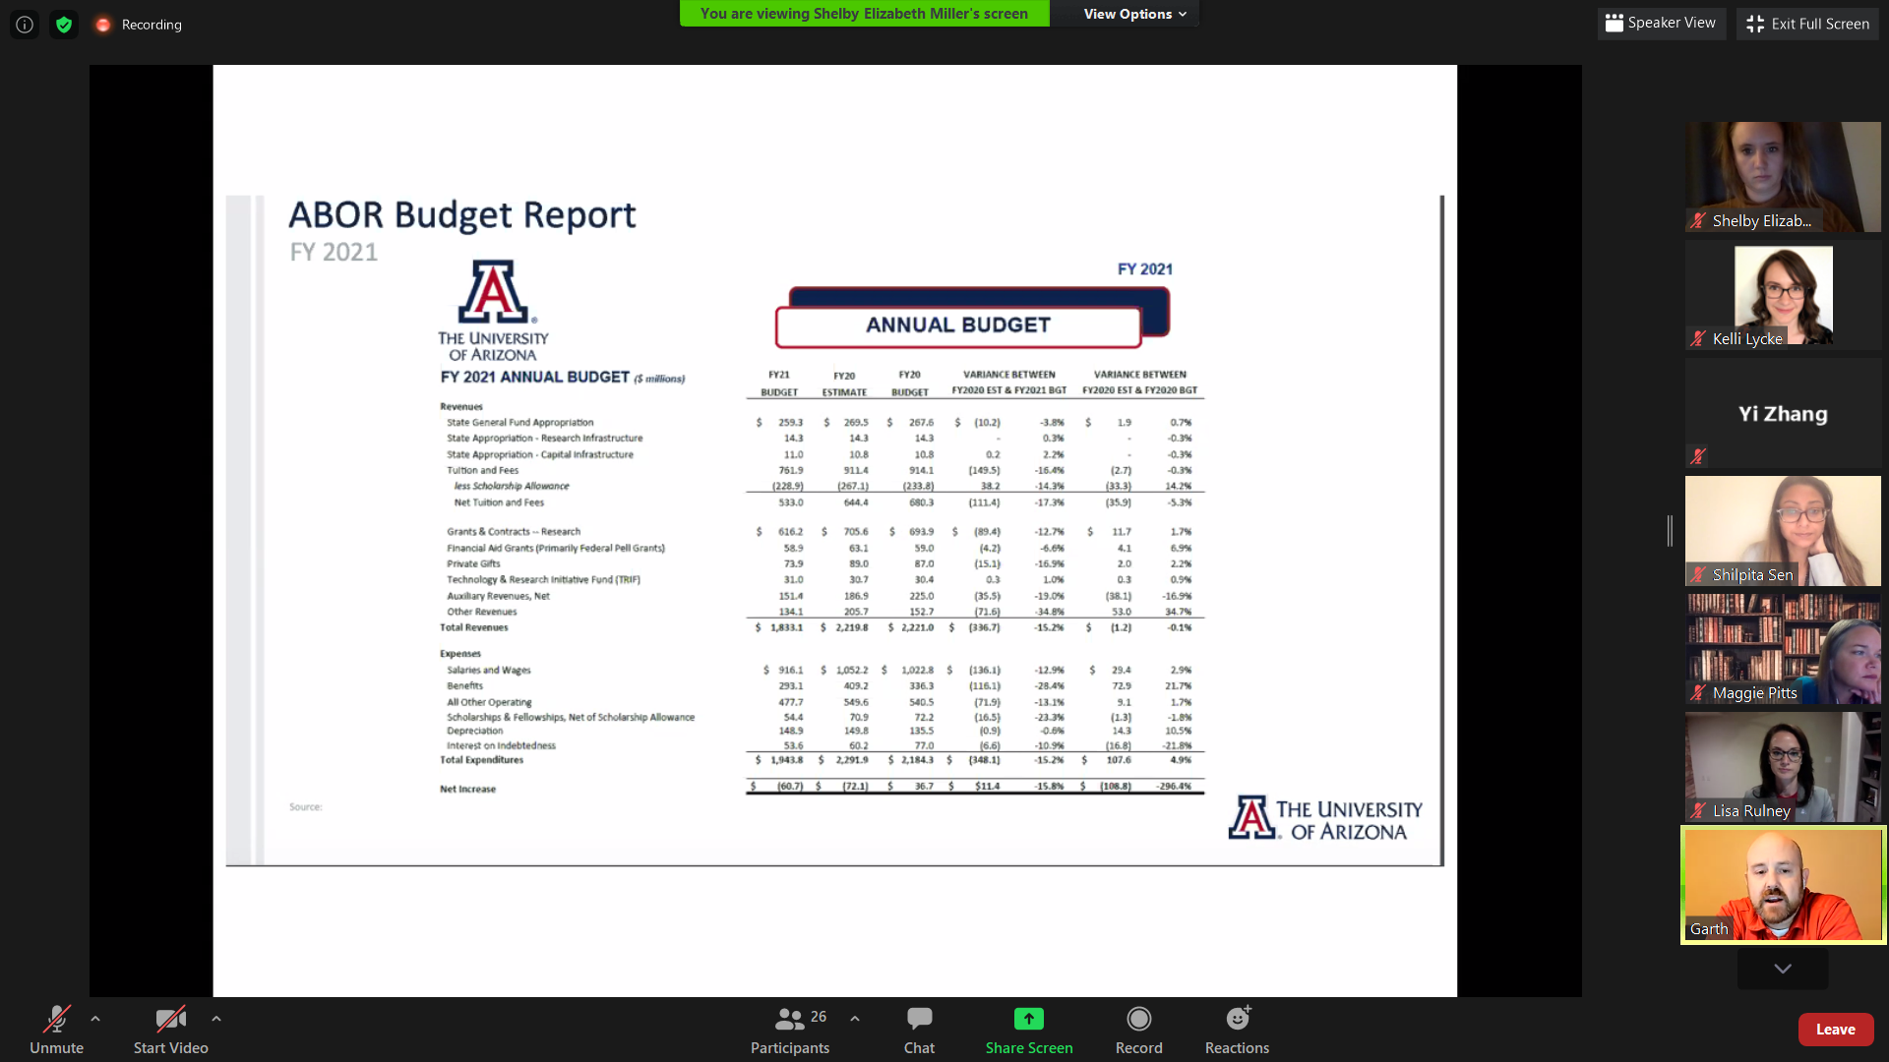
Annual Operating Budget. Total - 296 million

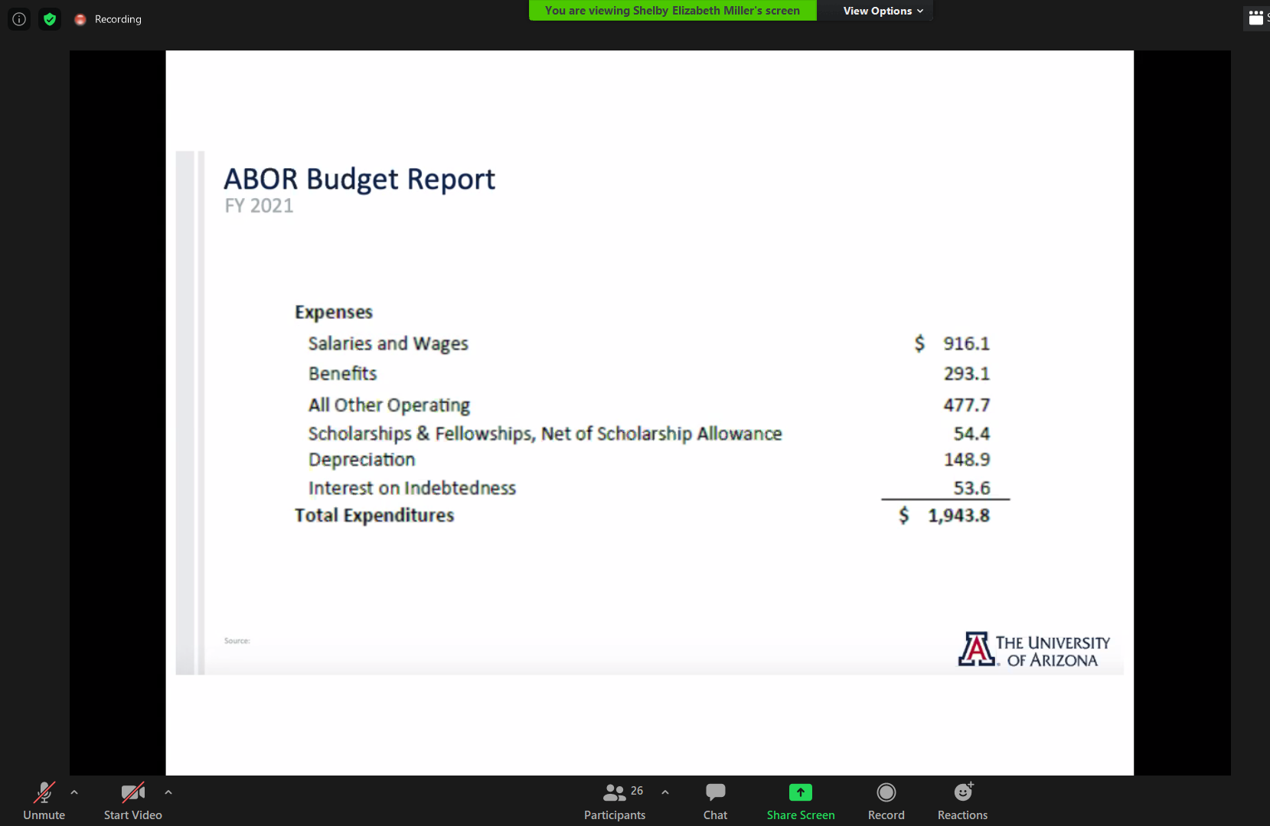
Annual Budget Breakdown. Depreciation is the maintenance of buildings and equipment. $1,943.8= 1.9 billion dollars

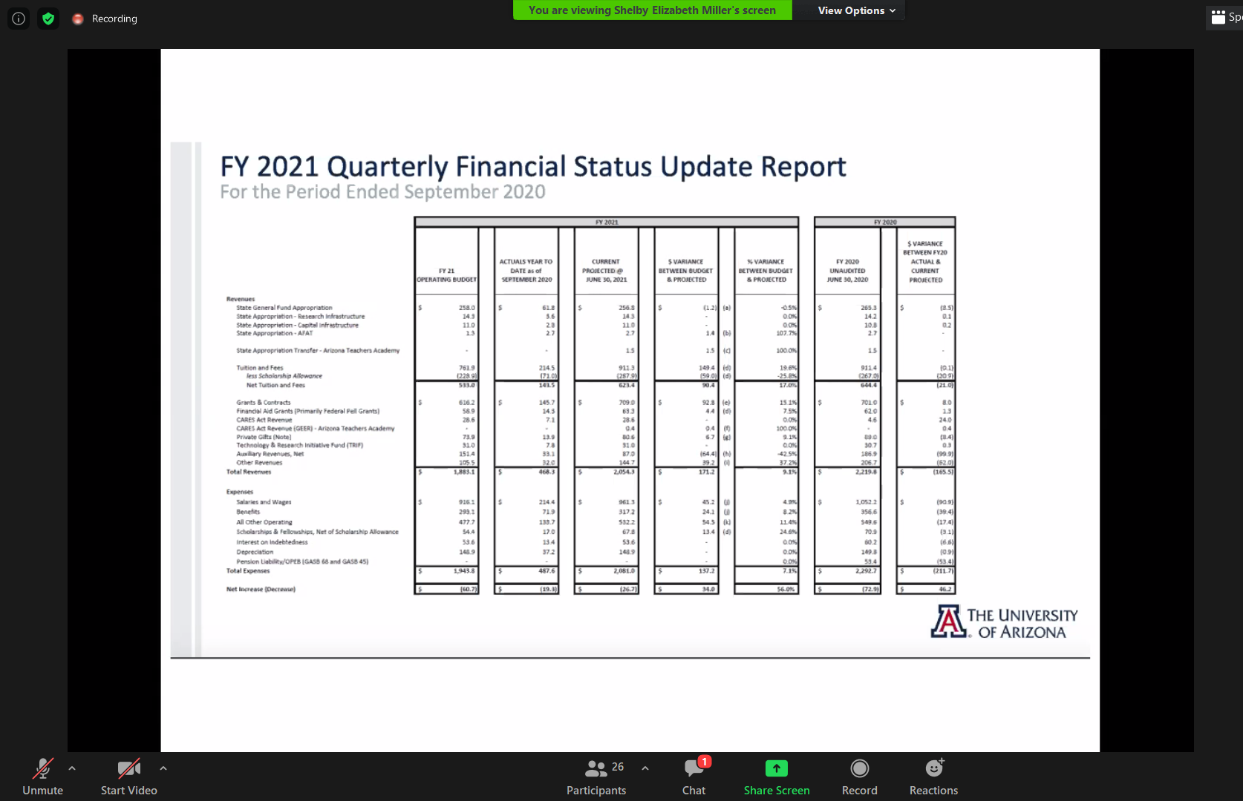
This is the revision of projections for the quarterly budget. Sorry it is so small! They expected large decreases in revenue (work from home to slow down research revenue), however it looks uninterrupted so far. Higher matriculation and enrollment for undergraduates also higher than expected. However, we lost a lot of International students because of visa issues. We also lost non-resident students.

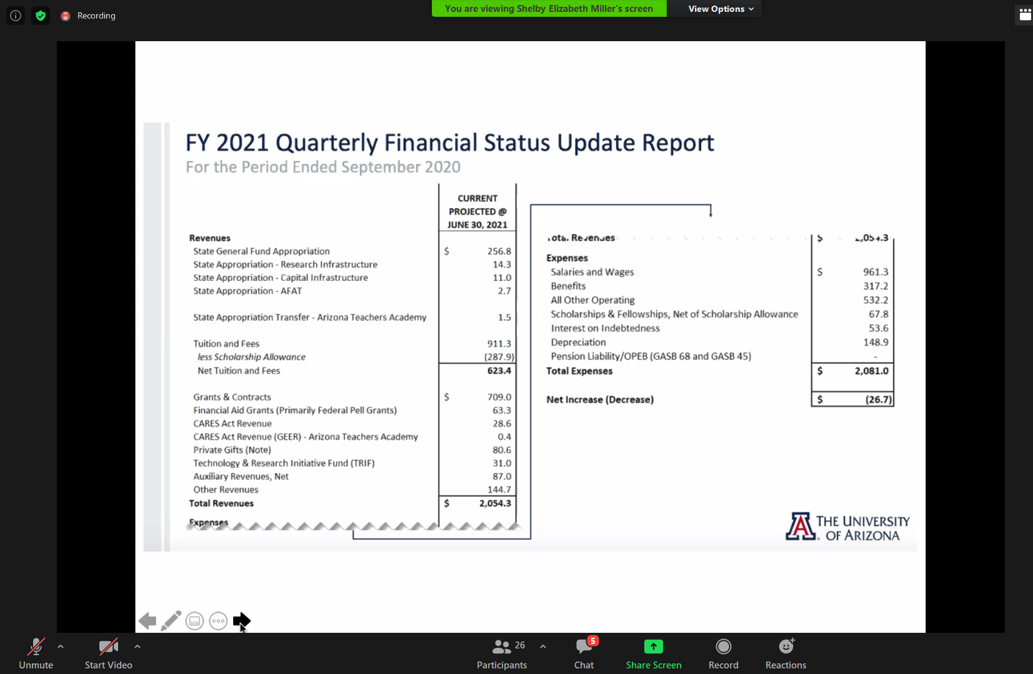
Projected loss for fall 2020. Athletics, parking, and bookstore (auxiliary) projected to take the most loss. [in terms of millions]

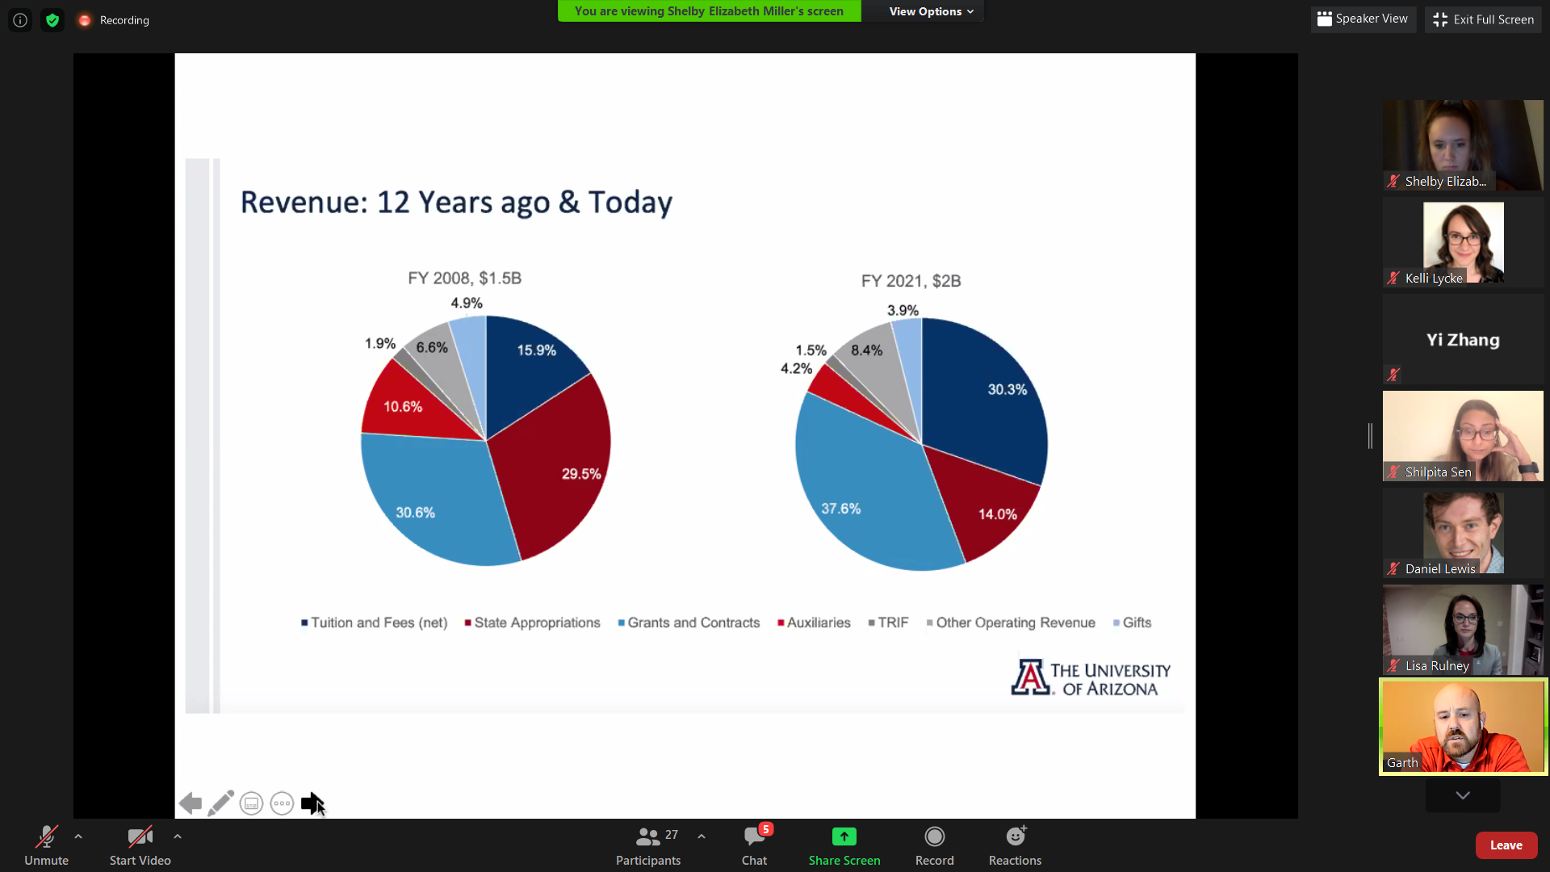
Changes in revenue since 2008.

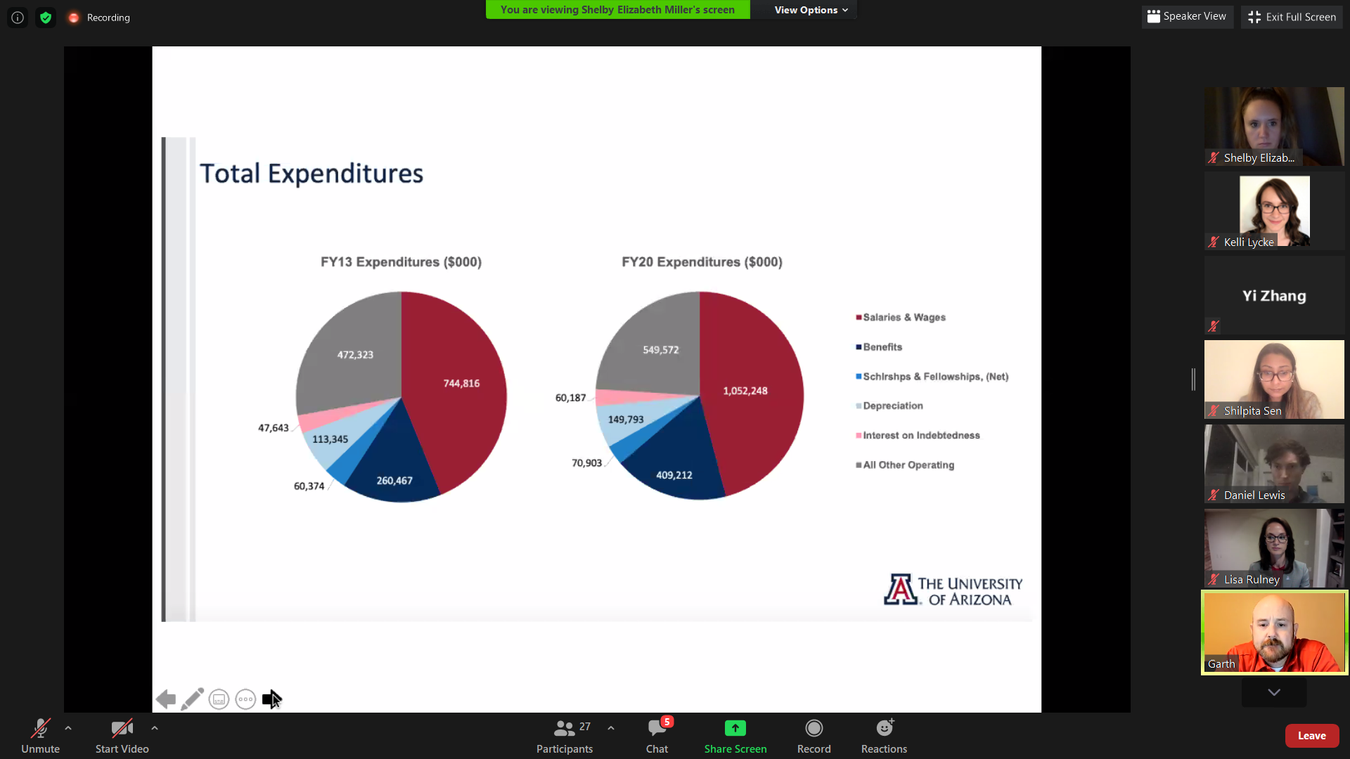Expense changes since 2013

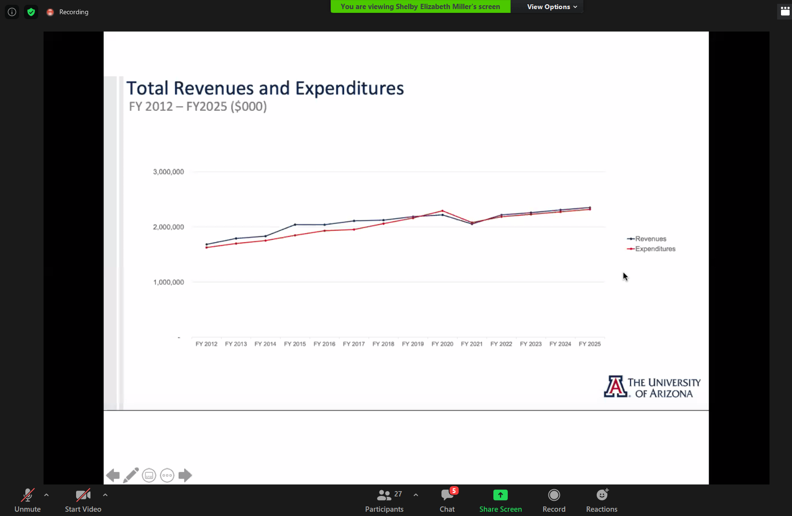
self explanatory

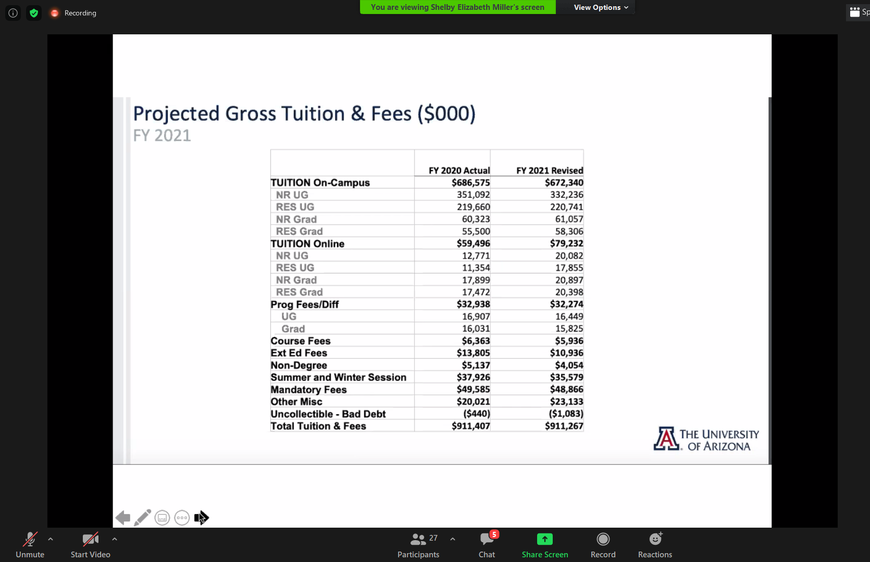
Projected Tuition and fees 2021. Misc = dissertation fees, candidacy fees, and library fees, ect.

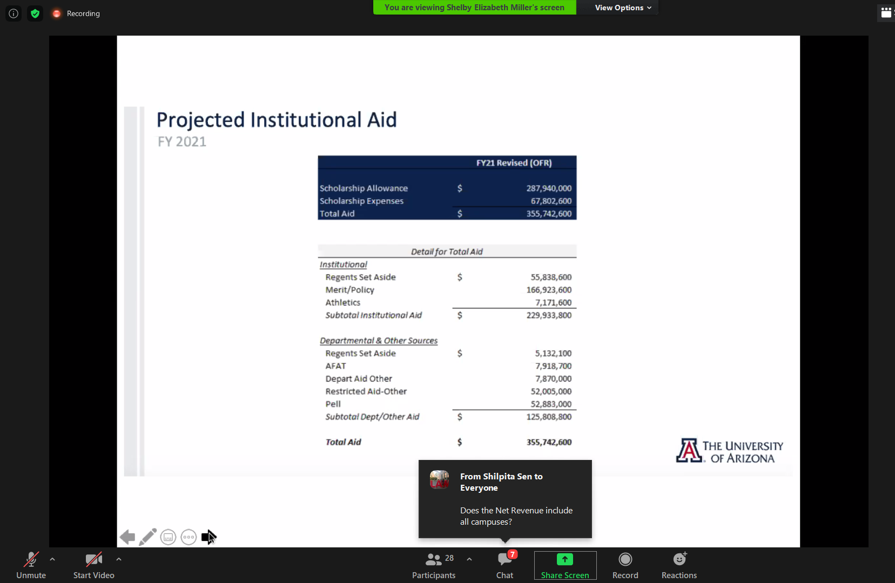
Break down of financial aid offered (expense)

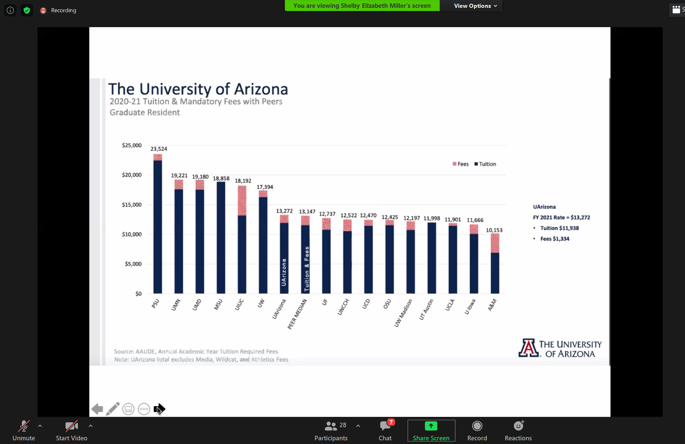
Comparison of resident Grad tuition and fees compared to “peer institutions.” Slightly above median. (land grant, school of agriculture, college of medicine, R1)

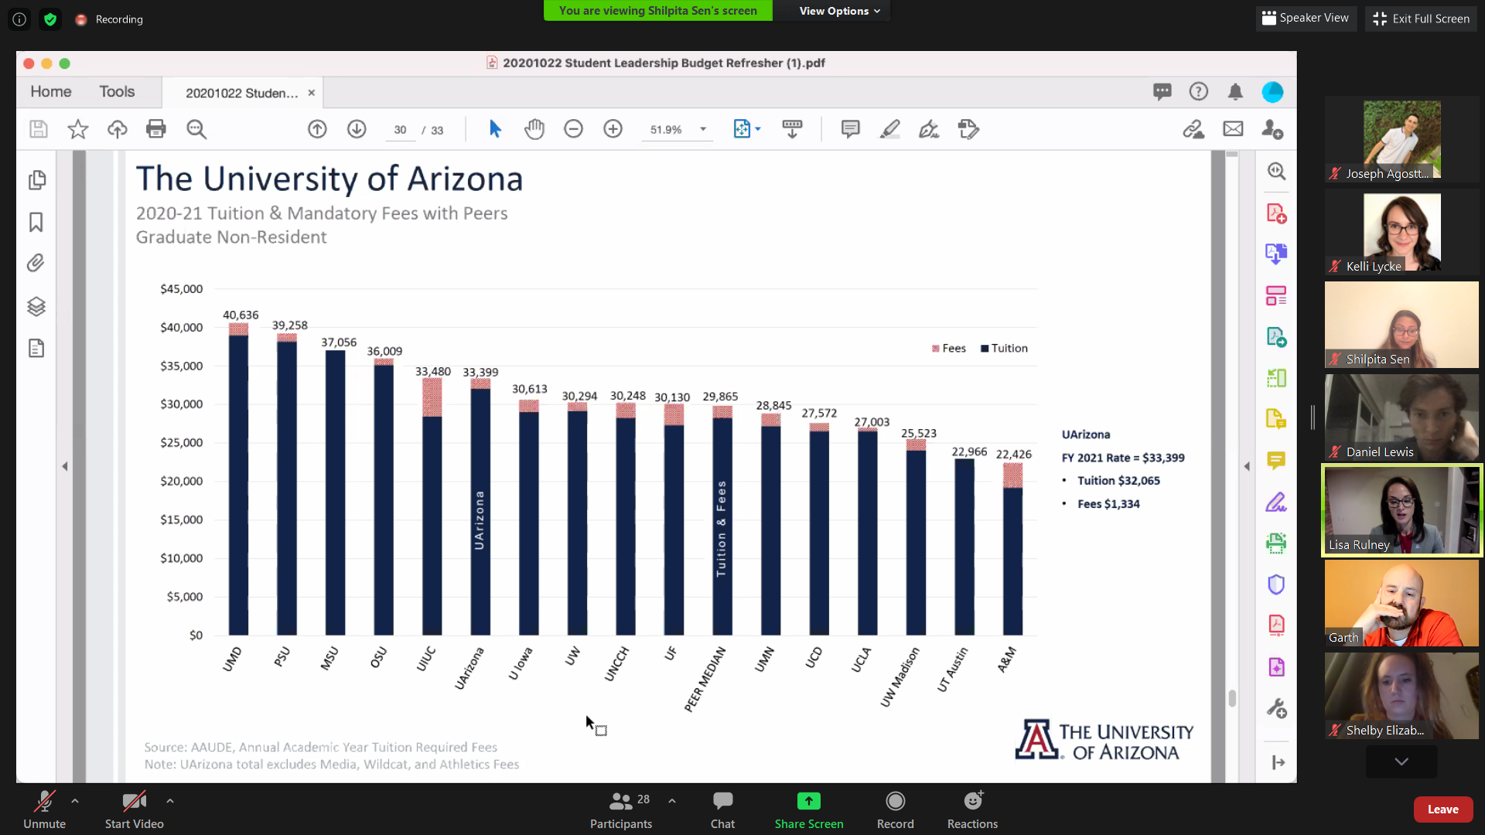
Graduate non-resident tuition and fees. well-above median of peer group.

